Differences Between Warrants & Options

Stock options and Stock warrants are two extremely popular derivative instruments that are traded in stock and derivative exchanges all over the world.

Because stock options and warrants share the same leverage characteristics, they have been commonly assumed to be the same instrument called different names. Nothing is further from the truth. Even though stock options and stock warrants behave in almost the same fashion and can be traded in the same fashion, they are actually fundamentally different instruments.

Even though a tiger roars like a lion roars, they are actually different animals with their own unique characteristics. Similarly, stock options and warrants have their own characteristics as well.

- Contracting Parties
Stock options are contracts between a person or institution owning a stock or willing to buy a stock and another person who either wants to buy or sell those stocks at a specific price. Read our Stock Options Tutorial for full explanations. In this aspect, stock options are just like the option you sign when you buy a house from a seller of that house. It's a contract between a party who owned the stock through purchase from the open market and another party who wish to buy that stock from the writer of the options contract. It is essentially a contract between two investors. In this aspect, a Market Maker is an investor as well because they too accumulate those stocks and options from the open market.
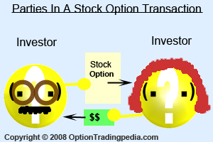

Stock Warrants on the other hand are contracts between investors and the bank or financial institution issuing those warrants on behalf of the company whose stocks the warrants are based on. When you buy warrants, it is these financial institutions selling it to you and when you sell warrants, it is these same financial institutions buying from you and not another investor. Companies issuing warrants do so in order to encourage the sale of their shares and to hedge against a reduction in company value due to a drop in their company share price. Therefore, when you buy a warrant, you are helping the company issuing it no matter if it gets exercised or not. However, in a stock option transaction, the company itself does not receive a direct benefit at all. It is the winning investor who enjoys the profits. The issuing bank or financial institution also acts as market makers for the warrants that they issue, hence there are no third party market makers like those making markets for stock options.
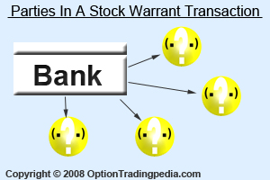
- Customizability of Terms of Issue
Standardized stock options all around the world are issued with a fixed structure and framework with a common method of calculation, standardized policy of strike difference, standardized contract size and standardized terms of exercise / delivery. All these rules are set by the individual exchanges so that all participants may "play this game" on equal terms. This standardization is necessary as stock options are contracts between individual investors who may not be professional financial institutions.
Warrants, however, are highly customizable as the issuer crafts the terms of each new issue according to their needs at that point in time. The most significant of these customizable terms is what is known as the "conversion ratio" or "cover ratio". Conversion ratio is simply the number of stocks that are represented with each warrant contract. This conversion ratio varies with each warrant contract unlike the fixed contract size in stock options. In fact, each warrant contract may even convert to just a fraction of the underlying share rather than the 100 or 1000 shares in stock options. The life span of warrants are also commonly much longer than options as the issuers are free to decide on an expiration date that could go as far as 15 years in some countries.

- Shorting
Because stock options are contracts between individual investors, anyone could produce a new option and throw it for sale into the market by "shorting" or "writing" using a Sell To Open order. Warrants, on the other hand, are issued by the issuing bank or financial institution only, hence they cannot be shorted.

- Exercise & Delivery
Stock options are either American, allowing the investor to exercise at any time during the life of the options, or European style, allowing the investor to exercise only during expiration. Warrants are only European style, which are automatically exercised during expiration if they are in the money. Remember, the issuers of warrants are the issuing banks directly representing the companies issuing the shares. These companies win as long as their shares get sold and capital raised. This is unlike stock options where the investor selling the options could lose significant amount of money when call options they wrote gets in the money and then subsequently exercised.

- Pricing
Because warrants are European style only, it's extrinsic value is significantly lower than that of American style stock options. American style stock options have higher extrinsic value due to the added benefit of allowing the holder to exercise the options at anytime during the life of the stock options. The higher extrinsic value of american style options makes credit strategies much more profitable than European ones.

- Trading Strategies
As stock options can be bought or shorted, there are a myriad of hedging and trading strategies that can be used, including credit strategies. As stock warrants can only be bought, it can only be traded like stocks without the flexibility and versatility that stock options can offer. Get a full list of Options Strategies.

- Conclusion
Even though Warrants share the same trading characteristics of Stock Options, it is really a totally unique trading instrument. Warrants are created more like over-the-counter exotic options where the terms of each warrant is highly customizable to meet the needs of the issuer and then securitized and publicly traded. In fact, the very same warrants that are publicly traded in derivatives exchange are traded in over-the-counter markets (OTC) as well, while in the US, only non-standardized options are traded OTC. In short, warrants are a form of exotic option that are capable of being traded publicly.
Here is a list of main differences between Stock Warrants and Stock Options.
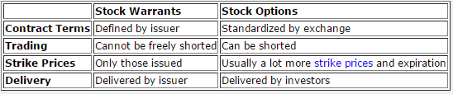

Due to these differences, especially the fact that warrants cannot be freely shorted, the hedging possibilities as well as the kinds of options strateiges that can be executed using warrants are a lot lesser than stock options. In fact, the only hedging strategies one can execute with warrants is the Protective Put strategy and delta neutral hedging using put warrants, which acts in almost the exact fashion as a put option.

